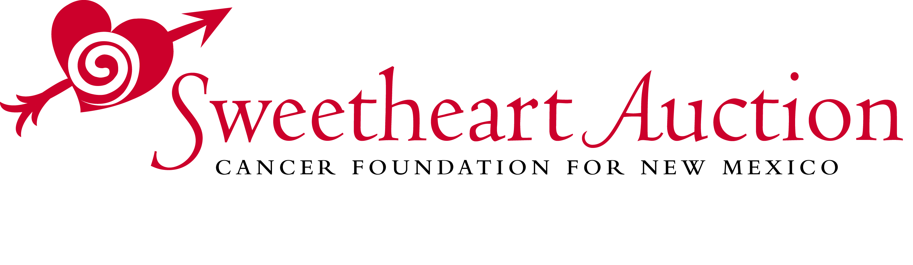
Sponsorship Agreement

Sweetheart Auction 2023

Saturday, February 11, 2023

Deadline: Friday, December 2, 2022

Business Sponsor
□ Lifesaver - $5,000 □ Rescuer - $3,000 □ Healer - $1,500 □ Friend - $800

Individual Sponsor
□ Lifesaver - $5,000 □ Rescuer - $3,000 □ Healer - $1,500 □ Friend - $800 □ Helper - $400

Please refer to the sponsorship brochure for details of the benefits at each sponsorship level*

Name [as it should appear in media]

Contact Person Phone______________________________

Email __________________________________________________ Fax________________________________

Address____________________________________City_______________________State_____Zip_________

□ I/We would prefer to be listed as anonymous
Note: Business logos should be in eps/vector format; ads should be in PDF format. Please send to bob@cffnm.org
Deadline: Friday, December 2, 2022

Do you want to do an Honor Wall Tribute: □ Yes □ No
Honoree Name______________________________________________________________________

Payment Method:
Check □ (payable to CFFNM) or Credit Card □ MasterCard □ VISA □ AMEX □ Discover
Card # __________________________________________________________Exp Date __________________

Name as it appears on card___________________________________________________________________

Billing Address __________________________________City_____________ State _____ Zip _____________

Signature ________________________________________________Date_____________________________

Payment must be made by Friday, December 2, 2022 unless other arrangements are made

Please mail this form with your payment to:
Cancer Foundation for New Mexico, P.O. Box 5038, Santa Fe, NM 87502
Forms can be faxed to 505-955-7900 or emailed to bob@cffnm.org

For additional information call Bob at 505-955-7931 x404; email bob@cffnm.org

All proceeds benefit the Cancer Foundation for New Mexico, a 501c3 corporation, Tax ID # 41-2079799.
Please consult your tax adviser as to the deductibility of your contribution.
*Benefits subject to change based on State of New Mexico health guidelines

